Human Resource Plan
LitPath AI: Smart Pathfinder for Theses and Dissertations

Asia Pacific College
3 Humabon, Magallanes
Makati City, Metro Manila 1232

April 1, 2026

Table of Contents
Introduction 3
Roles and Responsibilities 3
Project Organizational Charts 4
Staffing Management 5
Introduction
Human resources management is an essential component of the LitPath AI project. The human resources management plan serves as a guide for managing the team's human resource activities from project initiation through closure. The human resources management plan includes:
- Roles and responsibilities of team members throughout the project
- Project organization charts
- Staffing management plan to include:
  - How resources will be acquired
  - Timeline for resources/skill sets
  - Training required to develop skills
  - How performance reviews will be conducted
  - Recognition and rewards system

The purpose of the human resources management plan is to achieve project success by ensuring that the right team members are assigned to the appropriate roles, any skill gaps are identified and addressed through training, team collaboration strategies are clearly established, and all project activities are effectively coordinated and managed.

Roles and Responsibilities
The roles and responsibilities for the LitPath AI project are critical to its success. All team members must have a clear understanding of their individual roles to effectively contribute to the project. For the LitPath AI project, the following six roles and responsibilities have been established:

Project Manager (PM), (1 position): responsible for the overall success of the LitPath AI project. The PM must authorize and approve all project expenditures and ensure that all work activities meet established quality criteria and fall within acceptable variances. The PM is responsible for reporting project status in accordance with the communications management plan and for evaluating the performance of all project team members. The PM must possess the following skills: leadership, project planning, budgeting, scheduling, and effective communication.

Frontend Developer (FD), (1 position): responsible for designing and implementing the client-side interface of the LitPath AI platform. The FD oversees building responsive and accessible UI components, ensuring cross-browser compatibility, and collaborating with the backend developer on API integration points. The FD will provide timely status updates to the PM as required by the communications management plan. The FD may not authorize any project expenditure without PM approval. The FD must be proficient in HTML, CSS, JavaScript, and a modern frontend framework such as React or Vue.

Backend Developer (BD), (1 position): responsible for developing and maintaining the server-side logic, RESTful APIs, and database systems that power LitPath AI. The BD ensures data security, system reliability, and efficient communication between the application and its data sources. The BD coordinates with the Frontend Developer on API contracts and reports status to the PM per the communications management plan. The BD may not authorize project expenditures without PM approval. The BD must be proficient in a server-side language (e.g., Python, Node.js), database management (SQL/NoSQL), and API development best practices.

DevOps Engineer (DO), (1 position): responsible for managing the infrastructure, deployment pipelines, and operational reliability of the LitPath AI platform. The DO provisions and maintains cloud environments, automates build and deployment processes through CI/CD pipelines, and monitors system performance and uptime. The DO works closely with all developers to ensure consistent and stable environments across development, staging, and production. The DO will report infrastructure status to the PM via the communications management plan. The DO may not authorize project expenditures without PM approval. The DO must be proficient in cloud platforms (e.g., AWS, GCP, or Azure), containerization tools (Docker/Kubernetes), and CI/CD systems (e.g., GitHub Actions, Jenkins).

QA Tester (QA), (1 position): responsible for planning and executing all quality assurance activities for the LitPath AI project. The QA Tester designs and performs test cases covering functional, regression, and user acceptance testing across all features and components of the system. The QA Tester documents identified defects, tracks their resolution, and verifies fixes in coordination with the responsible developers. The QA Tester will report on testing progress and outcomes to the PM in accordance with the communications management plan. The QA Tester may not authorize project expenditure without PM approval. The QA Tester must be proficient in test planning, manual and automated testing tools, and defect tracking systems.

Project Organizational Charts
The following RACI chart shows the relationship between project tasks and team members. Any proposed changes to project responsibilities must be reviewed and approved by the project manager. Changes will be proposed in accordance with the project's change control process. As changes are made, all project documents will be updated and redistributed accordingly.

 | Project Manager | Frontend Developer | Backend Developer | DevOps Engineer | QA Tester
Requirements Gathering | A | R | R | C | C
System Architecture Design | A | C | C | C | I
UI/UX Design | A | R | C | I | C
Frontend Development | A | R | I | I | R
Backend Development | A | I | R | I | R
Database Design & Management | A | I | R | I | C
Infrastructure & Deployment | A | I | C | R | C
CI/CD Pipeline Setup | A | I | I | R | I
System Monitoring | A | I | I | R | C
QA & Software Testing | A | C | C | C | R
User Acceptance Testing | A | C | C | I | R
Documentation | A | R | R | R | R
Project Monitoring & Reporting | A/R | I | I | I | I

Key:
R – Responsible for completing the work
A – Accountable for ensuring task completion/sign off
C – Consulted before any decisions are made
I – Informed of when an action/decision has been made

Staffing Management

Staff Acquisition:
For the LitPath AI project, the project staff will consist entirely of internal HecTech resources. There will be no outsourcing or contracting performed within the scope of this project. The Project Manager will coordinate with stakeholders to identify and assign the appropriate team members in accordance with the project organizational structure. All resources must be confirmed and approved before any project work may begin. The project team may operate in a hybrid or remote arrangement depending on availability and project needs.

Resource Calendars:
The LitPath AI project is a continuing development effort spanning four months. Since major development has already been completed, all resources remain on standby throughout the project duration. The resource table below illustrates the estimated monthly hours for each team member. As the project is in its continuation phase, DevOps and QA Tester carry the heaviest workload at full capacity to maintain system reliability and ensure quality, while the Frontend and Backend Developers are available at minimal hours for minor fixes and adjustments only.

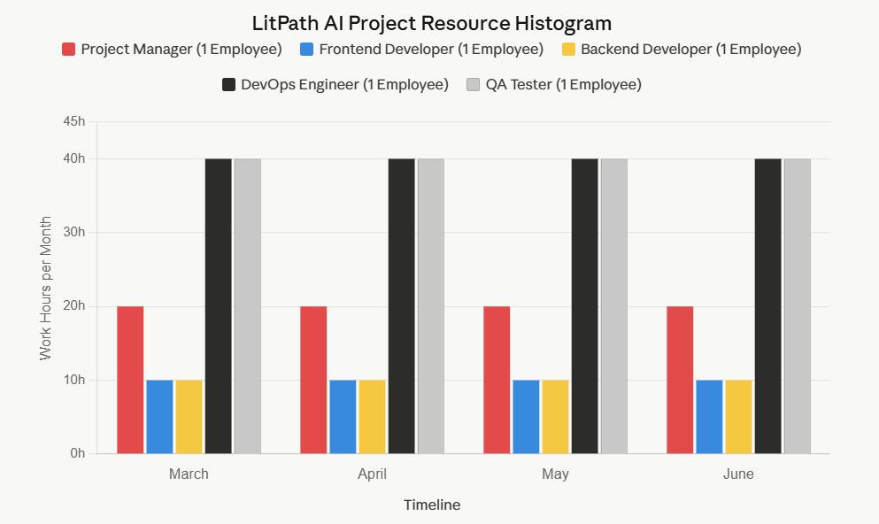

Training:
There is currently no formal training scheduled for the LitPath AI project as all team members possess the required skill sets for their respective roles. However, if training requirements are identified during the project such as adoption of new tooling, emerging technologies, or compliance requirements, the funding will be provided from the project reserve budget. The Project Manager is responsible for identifying and escalating training needs in a timely manner.

Performance Reviews:
The project manager will review each team member's assigned work activities at the onset of the project and communicate all expectations of work to be performed. The project manager will then evaluate each team member throughout the project to assess how effectively they are completing their assigned tasks. Prior to closing the project, the project manager will provide a formal performance summary for each team member. The following criteria will be used in performance evaluations:
- Timely completion of assigned work packages and deliverables
- Quality of outputs and adherence to project standards
- Collaboration and communication with team members
- Responsiveness to feedback and issue resolution

Recognition and Rewards:
Although the scope of this project does not allow for ample time to provide cross-training or potential for monetary rewards, there are several planned recognition and reward items for project team members.
- Upon successful completion of the LitPath AI project, a celebration will be held to recognize the contributions of each team member.
- Upon successful completion of the project, any team member who satisfactorily completed all assigned work packages on time will receive a certificate of thanks from the Project Manager.
- Team members who successfully complete all their assigned tasks will have their contribution highlighted in the HecTech SharePoint.

Sponsor Acceptance

Approved by the Project Sponsor:

Date: April 1, 2026
Khasian Eunice Romulo
Science Research Specialist II / Unit Head
(Digital Information and Processing Delivery Unit)

